Practical 13 File handling
There are basically two models of data that students will be using in assignment one:
- Insert the class Person.java into a new java project called it PPhoneBook. Copy into the top level of this folder the file Phone.csv.
  - Make your Person class implement Comparable and set a natural sort order of lastName then firstName.
  - In the app class declare an ArrayList of type Person and declare String variables for each property name.
  - In a while loop read the first line of the file, then use the String split method to create an array of Strings, name this array fields.
  - Fill each variable with the appropriate String field.
  - Create an instance of Person and load them into the Person array list.
  - Loop around to the next line
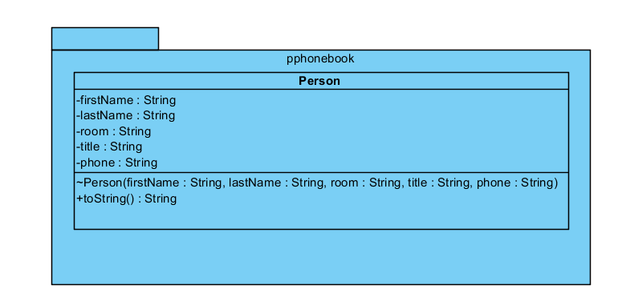
  - Prove it has all worked by printing to the screen the contents of the Person array list, you may need to edit the toString method.
- Create another project called PCDCollection copy the files Artist.java, Song.java and CDCollection.java into your project, at the top level of the project copy the file data.csv.
  - Set the natural sort orders for the Artist and Song class.
  - Declare the String variables name and line and an array list of artists. For this little example there are only 2 artists and exactly 3 songs each.
  - Read the first line of the file, which is the artist’s name.
  - Then read the next 3 lines (for loop) and create 3 Song instances feed these into a Song array list.
  - Fill up the first item in the Artist array list.
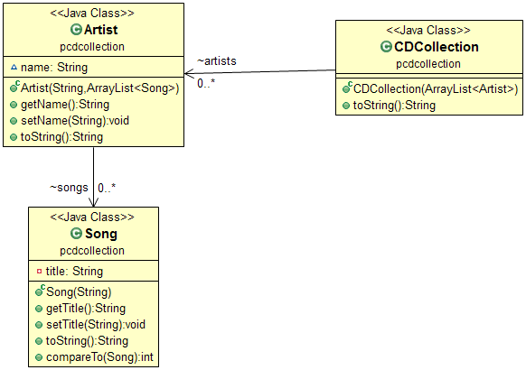
  - Loop around to the next set of data

  - Make an instance of CDCollection and print its toString method. Can you have the songs and artists in alphabetical order?

